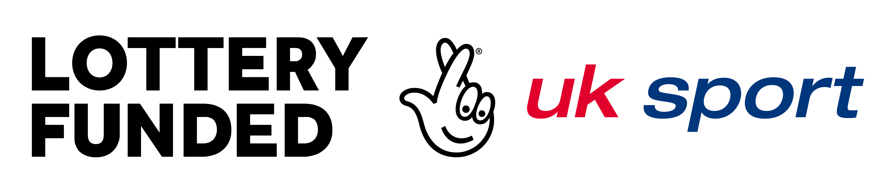

UK Sport Major Events Application

Governance and Organisational Structures
A new Sports Governance Code was launched in October 2016. The purpose of the code is to ensure appropriate governance is evident across the sporting sector and UK Sport expect this to be reflected in the governance of all funded events. Guidance as to best practice governance in Major Events has been issued to support applicants when they are considering the governance arrangements of their event.

The UK Sport Major Event Application process requires the provision of the following information:

- Governance Overview
- Local Organising Committee Organogram
- Local Organising Committee Roles and Responsibilities

Guidance related to the provision of these documents is provided below.

Governance overview
The governance overview requests that applicants provide information as to how the event will be managed. There is often a complex set of stakeholders involved in the overall management and detail on how this is structured should be provided. Roles and responsibilities should be defined and ways of working agreed between the parties.

Governance structure
- Detail which governance structure you will use to manage your event i.e. via an SPV or via a stakeholder’s internal team

- If an SPV – detail the arrangements i.e. wholly owned subsidiary or shared ownership? How will decisions be made? Which organisations are involved and what powers will they have?

- If internally delivered – detail where the ultimate responsibility sits i.e. with a stakeholder’s main Board? What authorities are delegated to the event board? How will the event board report to the group with ultimate responsibility? How will decisions be made? Which organisations are involved and what powers will they have?

Board composition
What is the intended composition of the Event Board? i.e Nominated representatives, Independent members, Chair, secretariat. Which organisations are represented and what powers will they have?

Governance plans
What other governance arrangements will you look to implement based on the recommendations provided in the Major Event Governance Guidance?

LOC Organogram and Roles/Responsibilities
As part of the application process applicants are requested to provide an example Organogram depicting the proposed event delivery team and responsibility areas. Each event will have its own organogram depending on the size and scale of the event and complexity of the sport and field of play.

The Senior Management Team description and organogram template detailed overleaf are provided as a starting point to explain the roles often found on a ‘standard’ event; however, the detail provided is not exhaustive as additional functions may need to be covered. These roles may require an individual manager or be amalgamated depending on the size and scale of the event and the budget for staffing, as well as the people available in the NGB, or external contractors, who have the time and skills to take on these roles and responsibility. The Organogram should detail internal NGB staff and external contracted roles and if possible highlight paid staff vs volunteer positions.

Organogram - template

Description of Proposed Senior Management Teams
Role | Description | How sourced? | Time Commitment | Cost to Budget and Annualised Salary
Event Director | Responsibilities may include:  - Reporting to Stakeholder Board  - Event LOC and event oversight  - Budget management  - Project Plan  - Risk Management  - Emergency planning and emergency services liaison  - Contingency and Readiness  - International Federation Liaison | e.g. External hire/ Partner Secondment/ Partner VIK/ NGB rep | e.g. 2 days a week for first 6 months and full time in the 6 months leading up to the event. | E.g. £40k to cover time commitment over 2 years (£20k per year)
Operations Manager | Responsibilities may include:  - Venue Operations  - Accreditation  - Security  - Cleaning  - Accommodation and Transport  - Catering, Cleaning and Waste | e.g.  NGB/ Venue /  Events Industry
Sport Manager | Responsibilities may include:  - Field of Play  - Athlete/team services  - Sport equipment  - Technical Officials  - Etc. | e.g.  NGB/  Sport
Volunteer Manager | Responsibilities may include:  - Recruitment  - Scheduling  - Reward and recognition  - Etc | e.g.  NGB  City Council  Event specialist or agency
PR, Marketing and Communication Manager | Responsibilities may include:  - Advertising  - Ticketing  - Event Promotion  - Press Operations  - Broadcast  - VIP Operations  - Etc. | e.g.  NGB  Communications Agency
Commercial Manager | Responsibilities may include:  - Sponsorship  - Ticketing (with Marketing Manager)  - Corporate Hospitality  - Merchandise and Licensing  - Etc. | e.g.  NGB  Sponsorship Agency
Culture / Community / legacy Manager | Responsibilities may include:  - Sport development and event legacy programmes  - Cultural and Arts Council links  - Etc. | e.g.  NGB  City Council  Local education provider
Business Services | Responsibilities may include:  - Financial accounting  - Contract drafting and legal support  - Administration  - Etc.  . | e.g.  NGB  Legal or insurance company

Provision of Contractors
Provide detail on any contractor groups that may be required for the delivery of the event

Area | Rationale | Where sourced | Time Commitment | VIK/Cash Cost to Budget
i.e. Accommodation and Transport

